AnyRes

Table of contents

Tutorial 1 1

New in AnyRes 1.1 4

Extra 4

## Tutorial 1

Let’s start from scratch. First expand the AnyRes folder and find the button texture. Select it and go to GameObject>Create Other>GUI Texture.

You should see your texture in the game preview: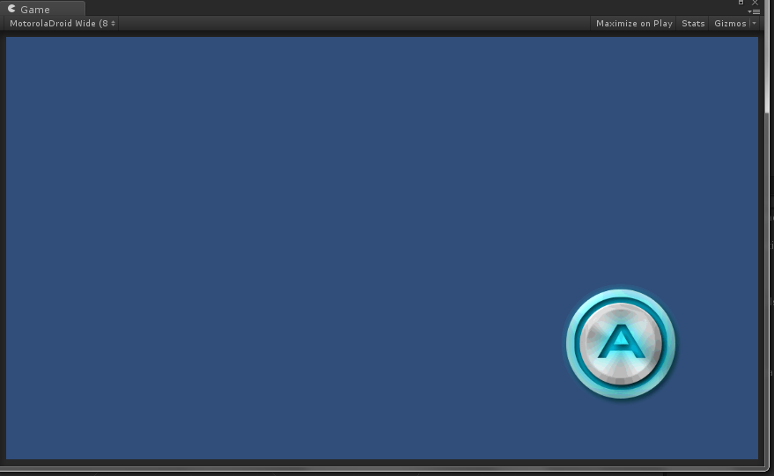

Next go to Window>AnyRes Setup. The AnyRes window should appear: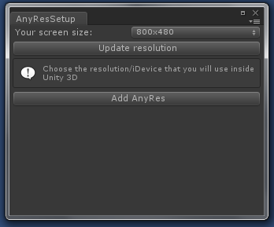

The first thing you want do to is to decide the screen resolution that you’ll be using while making your game.

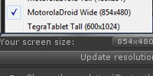

This is important because AnyRes won’t be able to calculate its things. (If you can’t find the resolution that you’d want to work with, select “free aspect” & click on “stats”, and find ”Screen: ”, then resize the window)

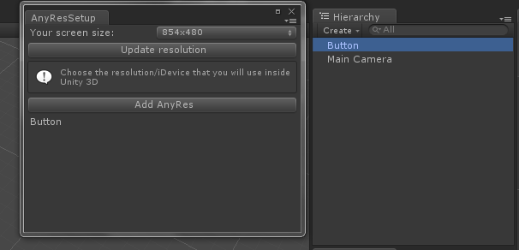

Select you GUITexture object and click on “Add AnyRes”.

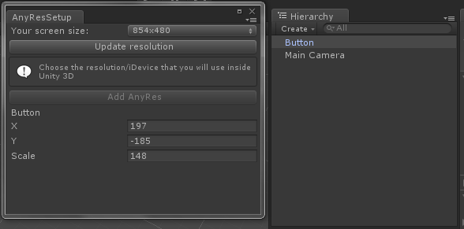

You can now easily position and scale the GUITexture!

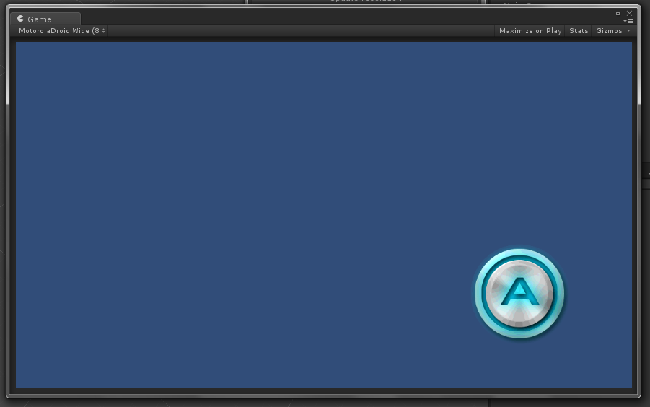

Once it looks good, change the game windows resolution and press play to see what happens!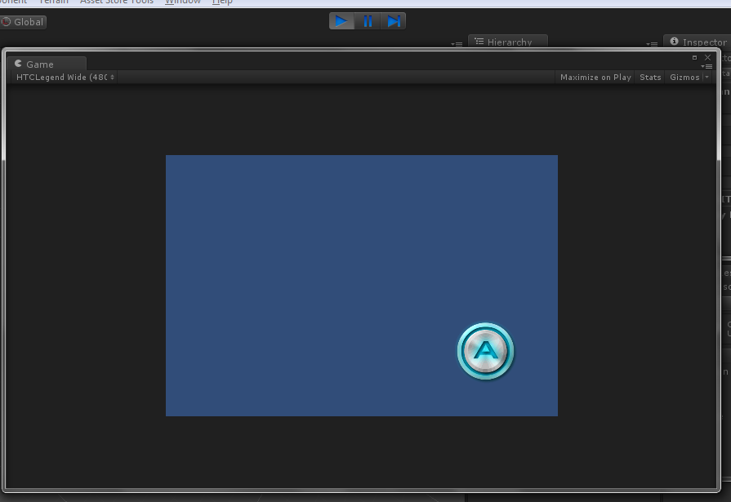

Your game can now be played at any resolution!



## New in AnyRes 1.1

Added support for GUIText!

Updated example scene

## Extra

1: AnyRes also includes a Simple Button Script (supports multitouch)!

2: If you want your GUITextures to fade in, you can check “Fade In”!

3: If you’d want to change the resolution in unity, simply change the resolution in AnyRes Setup window and click “Update resolution”. You’ll need to reposition your GUITextures but it can be easily done using the positioning and scaling tool that comes with AnyRes!